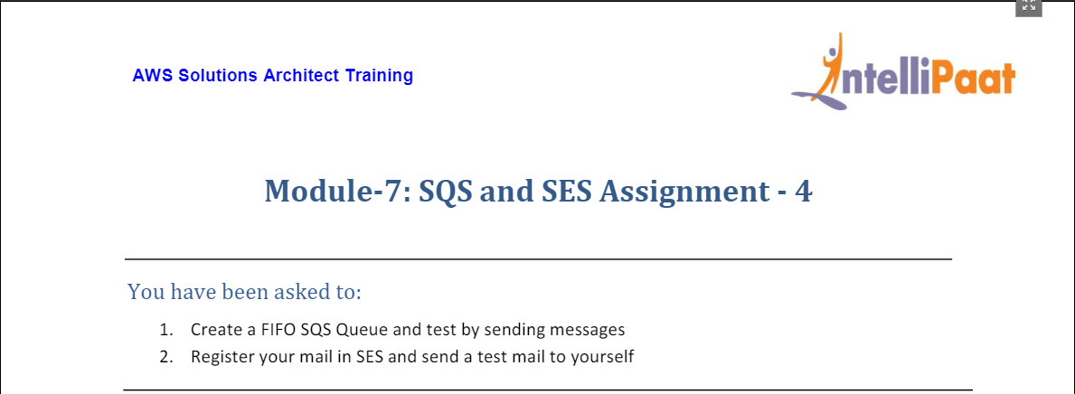

1. For this assignment, we head to SQS service from AWS Management Console and click on create queue (as shown below) :

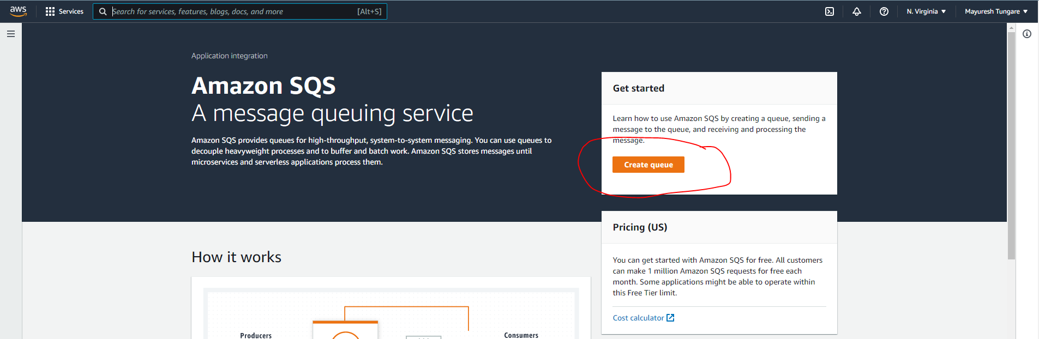

1. On the next screen, enter details and then click on ‘Create queue’ as shown below:

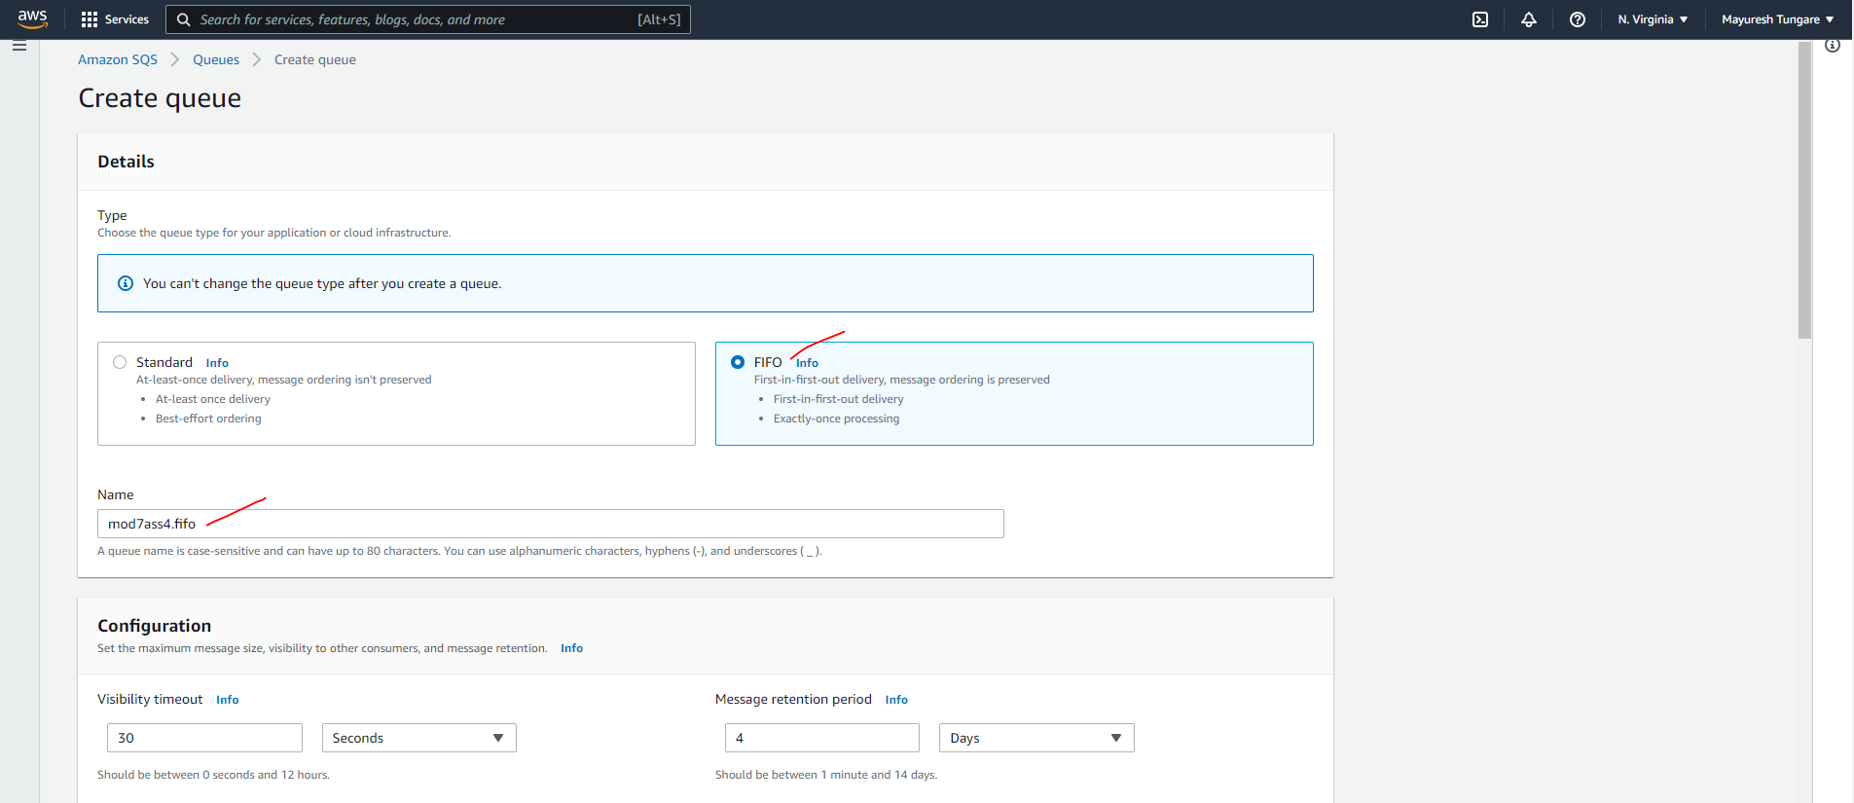

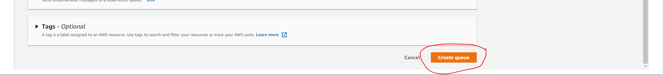

1. You will get a notification that the queue has been created successfully (as shown below)

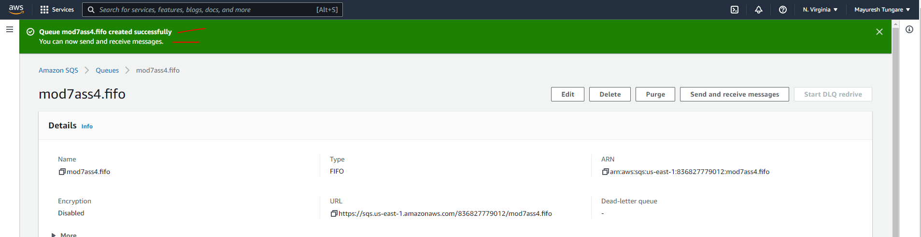

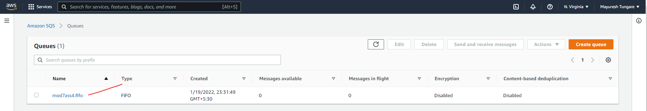

1. After this click on Send and receive messages as shown below:

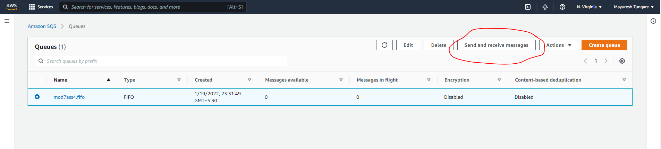

1. On next screen, enter details as shown below and click on ‘Send’:

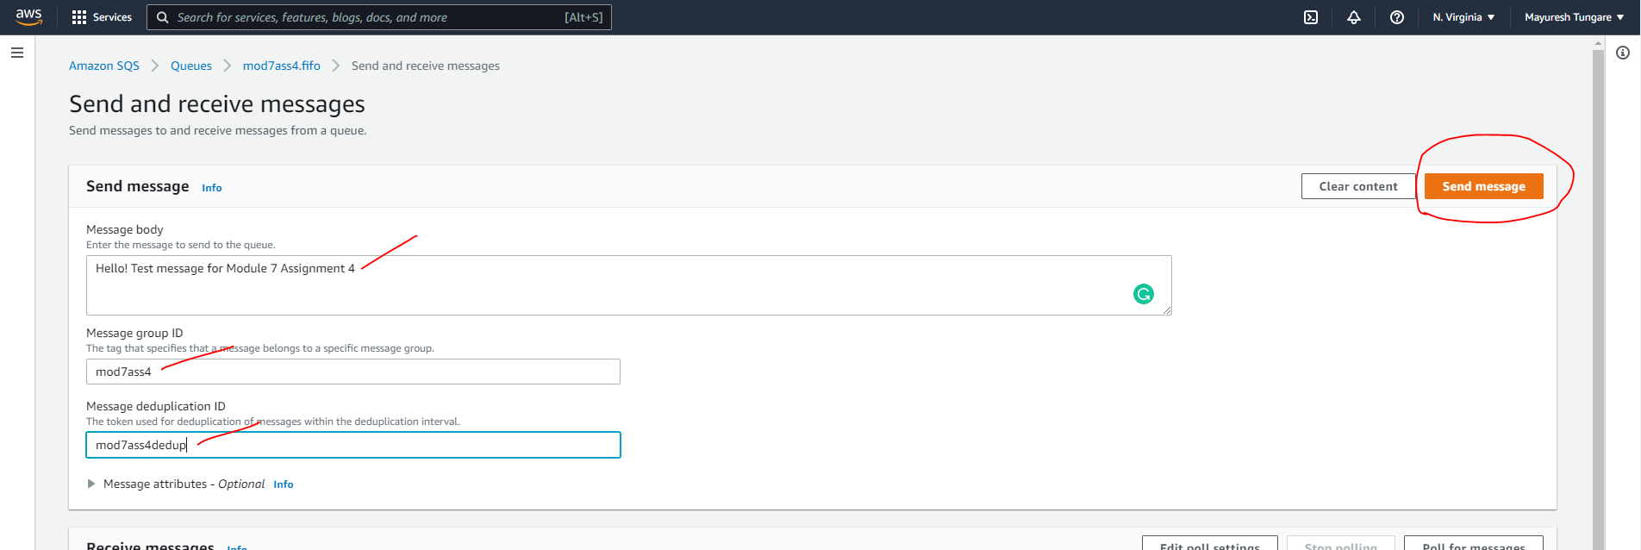

1. After click send, you can poll for messages as shown below:

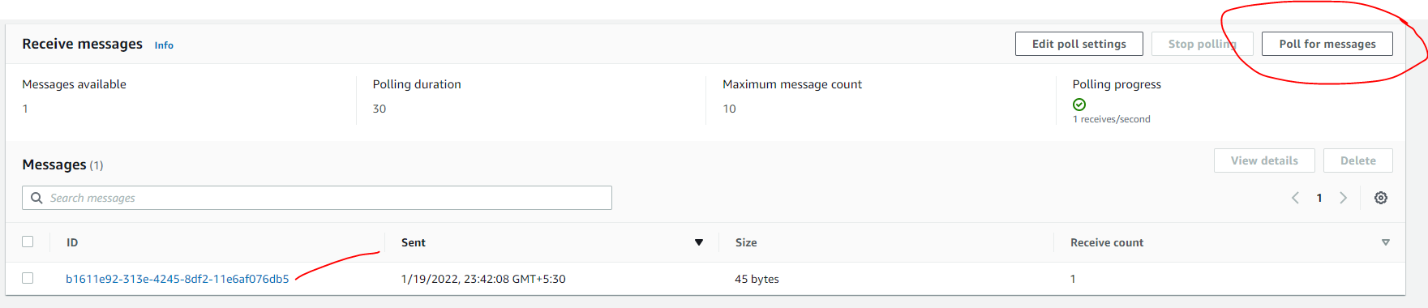

1. When you click on message, you see details as below:

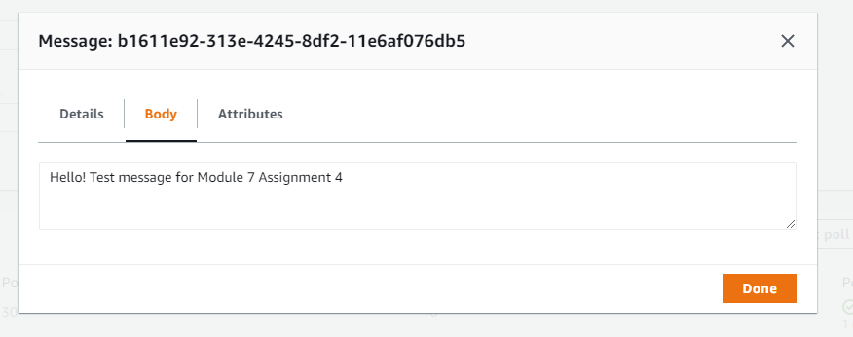

1. Next, access Amazon SES service through management console:

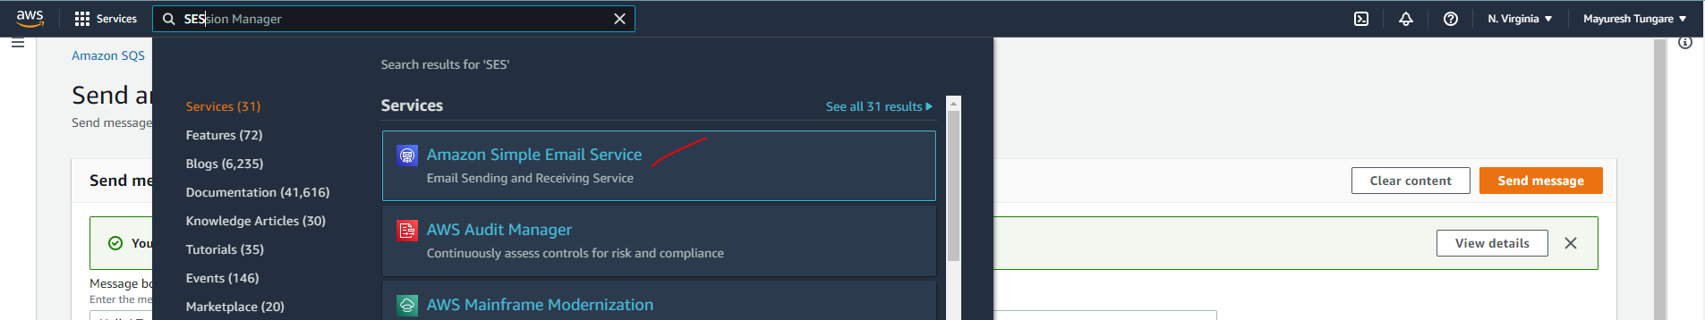

1. Next screen, click on ‘Create Identity’

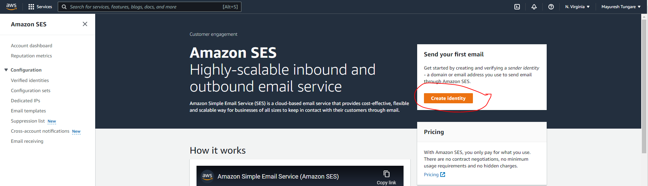

1. Next screen, enter details and click on ‘Create Identity’

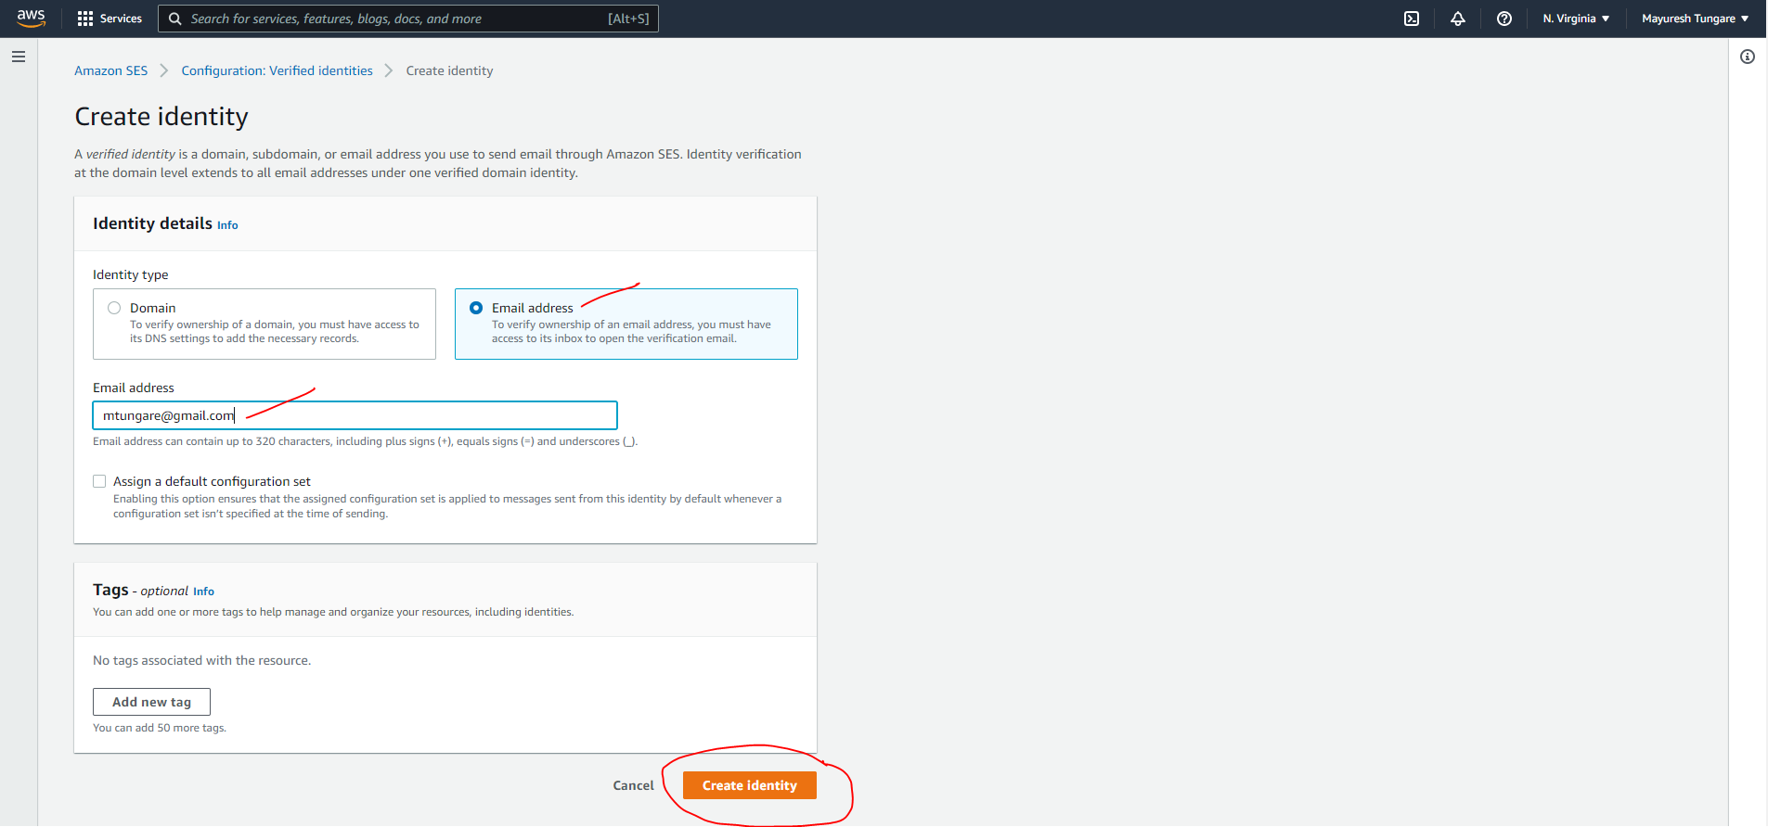

1. You will receive an email as below for verification. Complete the process.

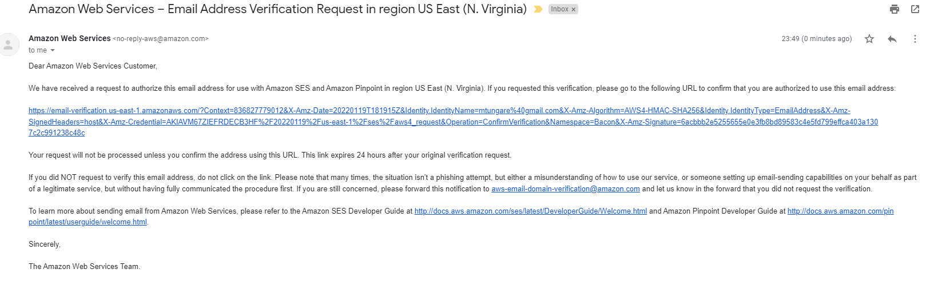

1. On successful verification, you will see the below message:

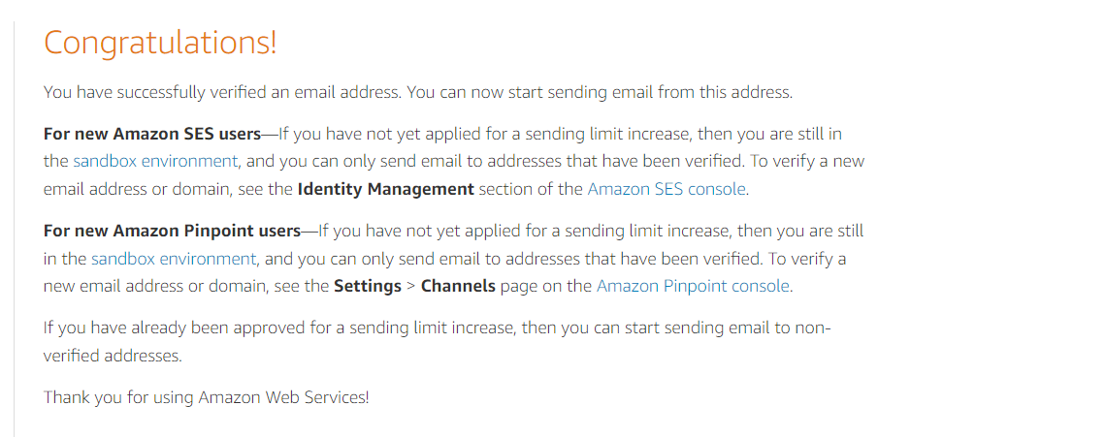

1. We now see email has been verified.

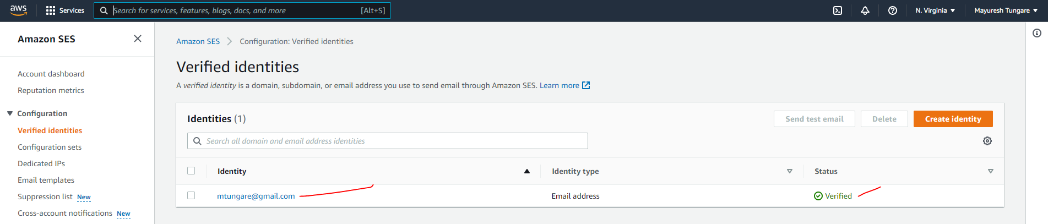

1. Next, we send a test email to ourselves as shown below:

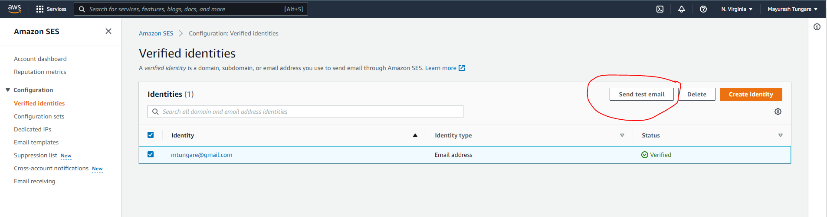

1. On next screen, enter details as shown below:

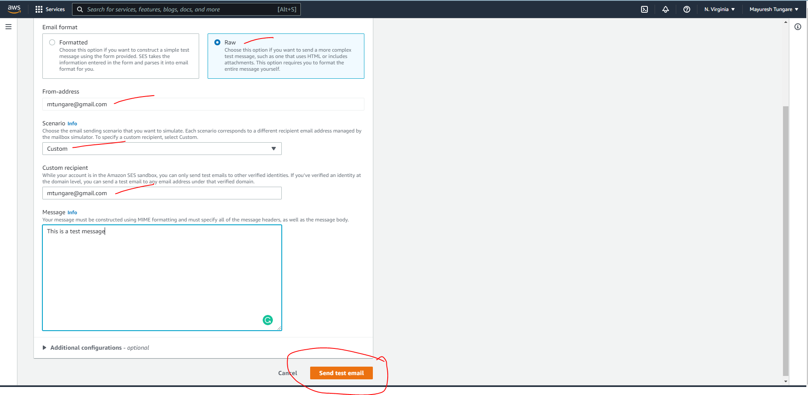

1. You will receive confirmation that test message has been successfully sent.

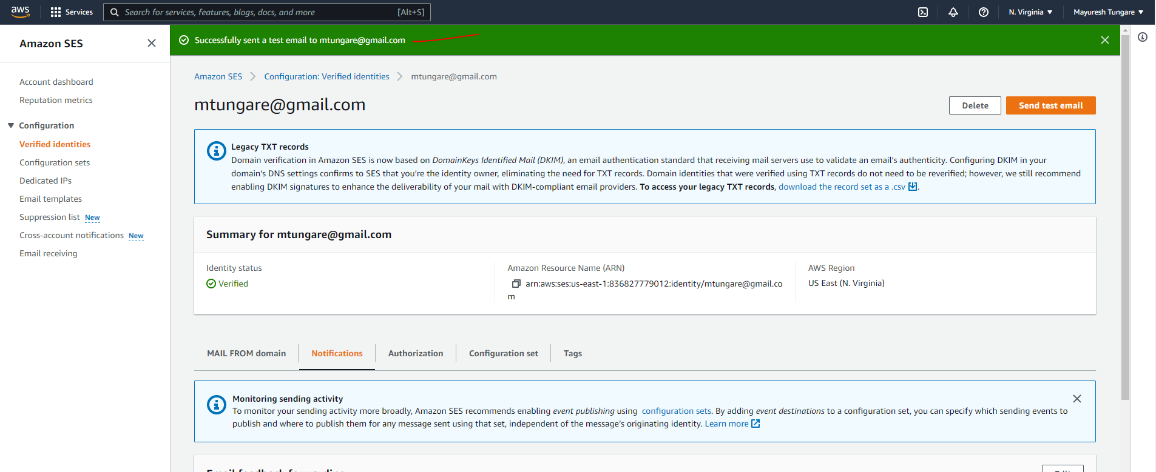

1. Thus, this assignment is now complete.